Student’s Name:
Professor’s Name:
Institution:
Calculating g from motion Lab report
Introduction
Gravity is one of the four fundamental forces of the universe. Gravity can be defined as the force by which a body or planet draws other objects towards its center. This is the force that keeps all the planets in orbit. Any object that has mass also has gravity, and its right to say for bodies with more mass have more gravity as well. The gravitational pull of the earth comes from its mass. This mass makes a gravitational pull to all bodies with mass and that’s what gives weight. I t is essential to study gravity for the wider understanding of all astrophysical bodies and the universe.
Objectives
- To learn how to analyze the motion of an object along an inclined plane and calculate g from that.
- To learn how to use interactive simulation tools.
Materials and Methods
Materials: Simulation tool with ramp and ball.
Procedure
- The base ramp was set at 50cm and for each height of ramp of the list below.
- The ball was put at the top of the inclined and the play button clicked.
- The time taken for the ball to reach the bottom of the inclined was read and recorded.
- For accuracy the pause and the step button were used till the ball was completely at the bottom of the inclined.
Results and calculations
Ramp height | Distance | time | Computed g | Accepted g | % error
10cm | 50.99 cm | 0.765 s | 8.89 m/s² | 9,81m/ s² | 9.4%
15 cm | 52.20 cm | 0.630 s | 9.16 m/s² | 9,81m/ s² | 6.6%
20 cm | 53.85 cm | 0.560 s | 9.25 m/s² | 9,81m/ s² | 5.7%
25 cm | 55.90 cm | 0.515 s | 9.43 m/s² | 9,81m/ s² | 3.9%
30 cm | 58.31 cm | 0.490 s | 9.45m/s² | 9,81m/ s² | 3.7%

Calculations
10 cm height
Acceleration= d- vt/0.5 t²
50.99cm – 0(0.765)/0.5*765²
=174.25cm/s2
174.25= g sinϴ
Sinϴ =10/50.99 = 0.196
174.25cm/s2/ 0.196cm = 889.03cm/s²
G = 8.89 m/s²
% error= (8.89-9.81)/9.81* 100 = 9.4%
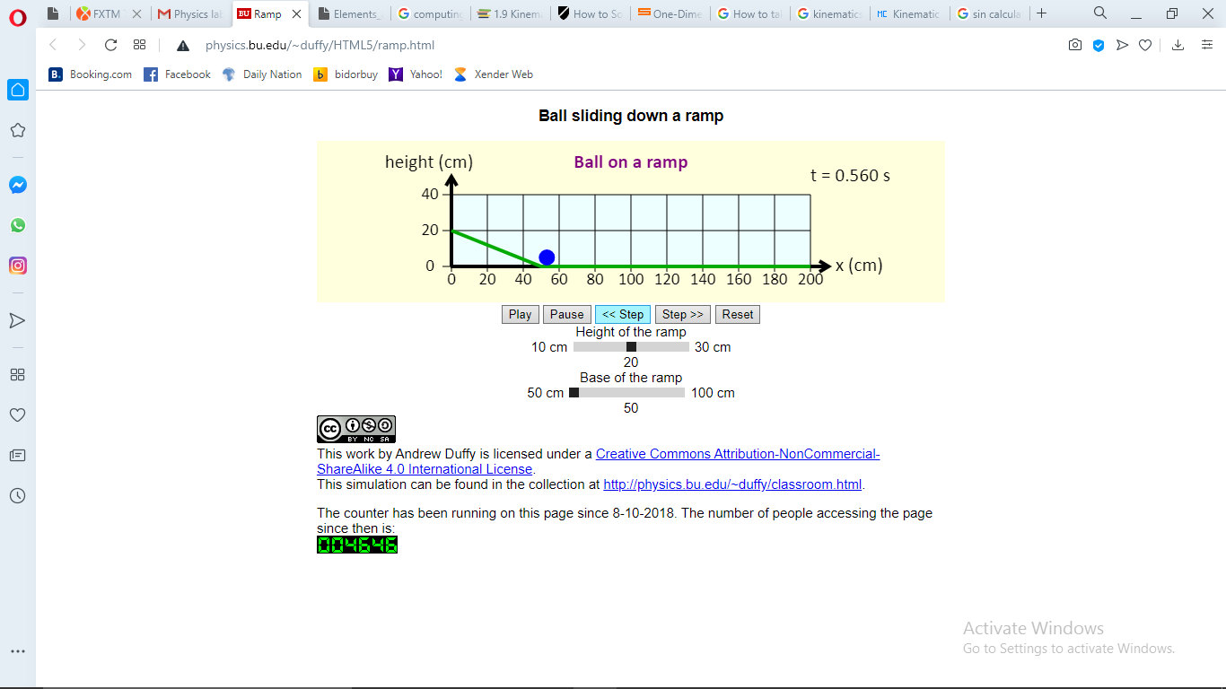
20 cm height calculation
Acceleration= 53.85- 0(0.560)/0.5*0.560²
⁼ 343.43cm/s2
A= g sinϴ
sinϴ= 20/53.85= 0.3714
343.43/0.3714 = 924.69cm/s2
G= 9.25m/s²
% error= (9.25-9.81)/9.81* 100 =5.7%
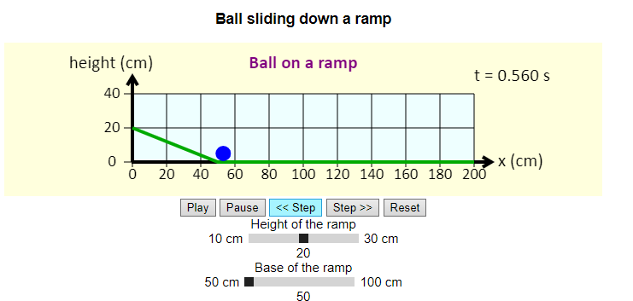
30 cm height calculations
Acceleration = 58.31 – 0(0.49)/0.5*0.49²
= 485.714cm/s²
A= g sin ϴ
Sin ϴ= 30/58.31= 0.514
485.714/0.514 = 944.97cm/s²
G= 9.45m/s²
% error= (9.45-9.81)/9.81* 100 = 3.7%
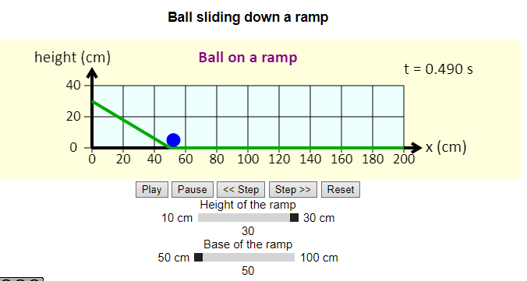
As seen from the calculations the higher the ramp was the more accurate the computed g came close to the accepted value. The percentage error decreased as the inclined height was increased.
Conclusion
In order to get precise g the prank should be completely vertical. In conclusion the simulated experiment was a success.
Questions
Displacement after 2seconds
D= v*t + ½ at²
⁼ 24 + (2.5)(4)
= 34m
After 5 seconds
D= v*t + ½ at²
= 60 + (2.5)(25)
= 122.5 m

